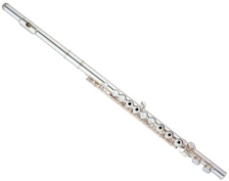
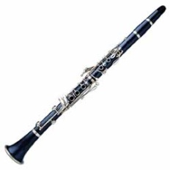
St. Stephens Band

Top Five Reasons to Join the Band


- It’s great fun!
- You’ll make new friends!
- You’ll learn something new!
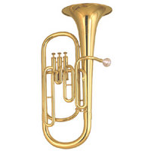
- Middle school and high school students who participated in instrumental music scored significantly higher than their non-band peers in standardized tests!
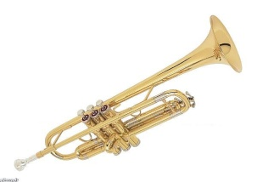
- Music participants received more academic honors and awards than non-music students!

Band Information/Registration night is Monday, August 31 from 7:00 to 8:30 in the SSM Diner for 5th, 6th, 7th and 8th graders. Instruments will be available for the students to try out and rent.

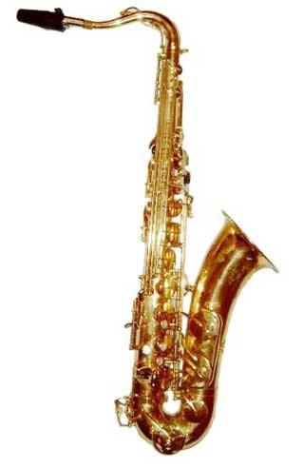
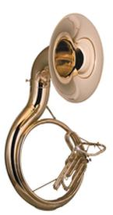
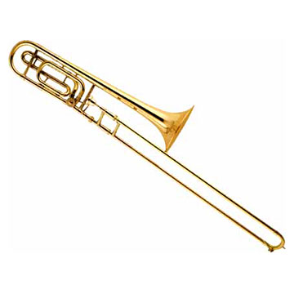
Questions? Call Mark Simerly at 991-9746 or email at simerlym@cox.net.

